
计算机与信息学院
数据结构实验报告

专 业 班 级 | 计算机科学与技术22-2班
学生姓名及学号 | 陈祥烨 2022212153
课程教学班号 | 0529822B-001
任 课 教 师 | 胡学钢
实验指导教师 | 李培培
实验地点 | C402
2022 ~2023 学年第 二 学期

实验 六 图的综合应用实验
实验时间∶ 2023年6月3日
预习内容
一、实验目的和要求∶
（1）掌握图的存储结构的设计与实现，基本运算的实现；
（2）掌握图的两种遍历算法、遍历生成树及遍历算法的应用；
（3）掌握基于图的关键路径、最短路径等实际问题求解的算法实现。
二、实验任务∶
<1> 设计一个无向图的类，并基于此图类实现以下功能：
（1）求给定图中的边的个数；
（2）判断一个该图是否是一棵树；
（3）用户自定义迷宫、入口和出口，设计算法寻找一条出入口之间最短的路径；
要求：给出测试案例验证相关运算求解结果。
<2>设计一个有向图的类，基于此类设计算法求解图6.1的关键路径 ；
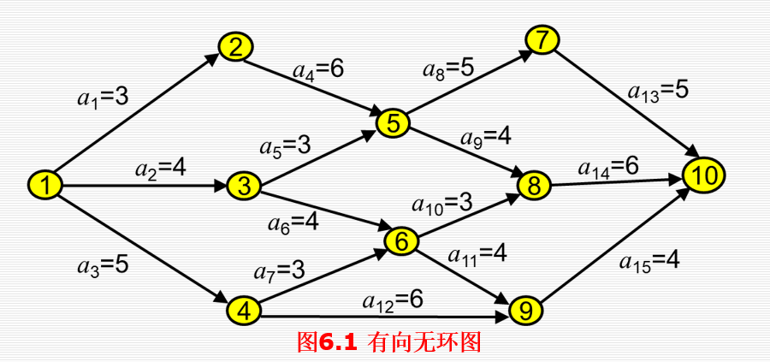
三、实验准备方案，包括以下内容：
<1>
迷宫的无线图较为特殊；所以将一二问和第三问分开来做。
- 因为是利用邻接矩阵edge[MAX][MAX]存储边相连的，所以得到边数的方法是遍历邻接矩阵，为1的话（if (edge[i][j] == 1)），边数+1；
- 利用深度遍历，遍历非前驱结点的邻接点，如果发现要遍历过得点已经遍历过，则不为树；
Graph类：
class Graph {
private:
int vertex[MAX]; //顶点表
int edge[MAX][MAX]; //边
int count; //当前定点数

public:
Graph() { count = 0; }
~Graph() {}

bool insert(int data); //插入点
bool connect(int point1, int point2); //连接

int getEdgeCount(); //获得边的数量
bool isTree(); //判断是否为树接口
int getCount() { return count; } //获得点的数量

private:
void isTree(int point1, int prepoint, bool visited[MAX], bool& flag); //判断是否为树接口
};
- 迷宫的存储方式是二维矩阵，可以走的地方为1，不可以为0，上下左右这是该点坐标的+1和-1，同样应用深度遍历试探，暴力测试，同时用栈记录步骤过程；

dfs算法流程：先访问该点设置是否走过xy.setPassed()，步骤入栈path.push(node)；然后判断是否已到终点，到终点，比较是不是最优解（步数最少），是则更新；没到终点，上下左右没走过的地方进行dfs；四个方向测试过后出栈path.pop()，该点走过的痕迹归零passed[xy.x][xy.y] = 0
class XY {
public:
int x;
int y;

XY() {}
XY(int x, int y);
bool isAccess();
void setPassed();
bool isEnd();
bool equals(XY xy);
};

<2>
对于给定的有向图，先进行拓扑处理，然后求出最长路径。

实验内容
一、实验用仪器、设备：
笔记本VS2022
二、实验内容与步骤（过程及数据记录）：
<1>
（1）（2）
代码：
Graph.h
#pragma once
#include<iostream>
using namespace std;
const int MAX = 100;

class Graph {
private:
int vertex[MAX]; //顶点表
int edge[MAX][MAX]; //边
int count; //当前定点数

public:
Graph() { count = 0; }
~Graph() {}

bool insert(int data); //插入点
bool connect(int point1, int point2); //连接

int getEdgeCount(); //获得边的数量
bool isTree(); //判断是否为树接口
int getCount() { return count; } //获得点的数量

private:
void isTree(int point1, int prepoint, bool visited[MAX], bool& flag); //判断是否为树接口
};

inline bool Graph::insert(int data){
if (count == MAX) {
return false;
}
vertex[count] = data;
count++;
return true;
}

inline bool Graph::connect(int point1, int point2){
if (point1 >= count || point2 >= count) { //越界不连
return false;
}
if (point1 == point2) { //相同不连
return false;
}
if (edge[point1][point2] == true && edge[point2][point1] == true) { //已连不连
return false;
}
edge[point1][point2] = true;
edge[point2][point1] = true;

return true;
}

int Graph::getEdgeCount() {
int edgeCount = 0;
for (int i = 0; i < count; i++) {
for (int j = 0; j < count; j++) {
if (edge[i][j] == 1) {
edgeCount++;
}
}
}
return edgeCount / 2;
}

bool Graph::isTree(){
bool visited[MAX];
for (int i = 0; i < count; i++) { //初始化
visited[i] = false;
}
bool flag = true;
isTree(0, 0,visited, flag);
return flag;
}

void Graph::isTree(int point, int prepoint, bool visited[MAX], bool& flag) //深度优先
{
if (flag == false) { //已经确定不为树，则直接返回
return;
}
if (visited[point] == true) { //如果该点已被探索过，则不为树
flag = false;
}
visited[point] = true;
for (int i = 0; i < count; i++) { //广度遍历邻接点
if (prepoint!= i && edge[point][i] == 1) {
isTree(i, point, visited, flag);
}
}
}
Main.cpp
#include<iostream>
#include"Graph.h"
using namespace std;

void test1() {
cout << "test1:" << endl;

Graph garph;
for (int i = 0; i < 9; i++) {
garph.insert(i);
}

garph.connect(0, 1);
garph.connect(0, 2);
garph.connect(0, 3);
garph.connect(1, 4);
garph.connect(1, 5);
garph.connect(2, 6);
garph.connect(2, 7);
garph.connect(3, 8);

cout << "边数：" << garph.getEdgeCount() << endl;
if (garph.isTree()) {
cout << "是一棵树" << endl;
}
else {
cout << "不是一棵树" << endl;
}
}

void test2() {
cout << "test2:" << endl;

Graph garph;
for (int i = 0; i < 9; i++) {
garph.insert(i);
}

garph.connect(0, 1);
garph.connect(0, 2);
garph.connect(0, 3);
garph.connect(1, 4);
garph.connect(1, 5);
garph.connect(2, 6);
garph.connect(2, 7);
garph.connect(3, 8);
garph.connect(0, 8);

cout << "边数：" << garph.getEdgeCount() << endl;
if (garph.isTree()) {
cout << "是一棵树" << endl;
}
else {
cout << "不是一棵树" << endl;
}
}

int main() {
test1();
test2();
return 0;
}
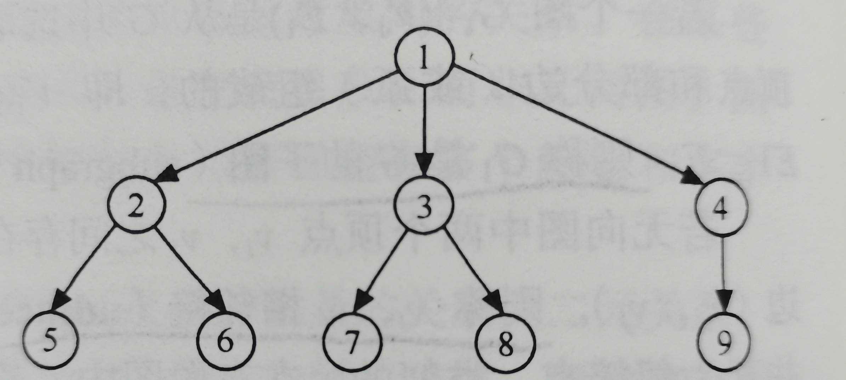
测试：
test1
test2：连接1和9

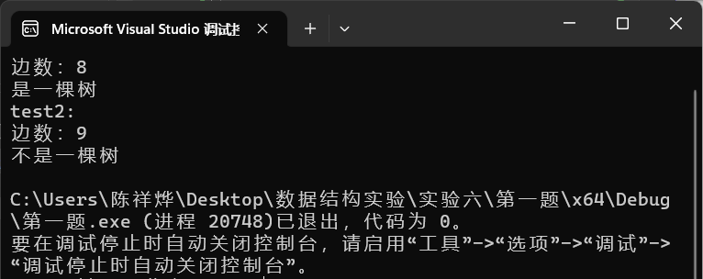
（3）
代码：
Stack.h
struct Node
{
int x, y;
Node* next;
Node() {};
Node(int x, int y) { this->x = x; this->y = y; }
};

class Stack
{
public:
Stack(); //默认构造函数
~Stack(); //析构函数
bool empty(); //判断栈空
bool get_top(Node*& x); //取栈顶元素
bool push(const Node* node); //入栈
bool pop(); //出栈
bool contains(Node* xy); //是否存在
int size(); //栈内容数量
void removeAll(); //清空栈
void addAll(Stack x); //拷贝
void addAll(Node* node); //拷贝
private:
int count; //总数
Node* top; //栈顶指针
};

//----------Stack类实现----------
Stack::Stack()
{
count = 0;
top = NULL;
}

bool Stack::empty()
{
return count == 0; //return top == NULL
}

bool Stack::get_top(Node*& x)
{
if (empty())
return false;
x = top;
return true;
}

bool Stack::push(const Node* node)
{
Node* s = new Node;
s->x = node->x;
s->y = node->y;
s->next = top;
top = s;
count++;

return true;
}

bool Stack::pop()
{
if (empty())
return false;
Node* temp = top;
top = temp->next;
delete temp;
count--;
return true;
}

bool Stack::contains(Node* xy) {
Node* temp = top;
for (; temp != NULL; temp = temp->next) {
if (temp->x == xy->x && temp->y == xy->y)
return true;
}
return false;
}

int Stack::size()
{
return count;
}

void Stack::removeAll() {
count = 0;
while (!empty())
pop();
}

void Stack::addAll(Stack x) {
Node* temp;
x.get_top(temp);
addAll(temp);
}

void Stack::addAll(Node* node) {
if (node != NULL) {
addAll(node->next);
push(node);
}

}

Stack::~Stack()
{
count = 0;
while (!empty())
pop();
}
Main.cpp
#include<iostream>
#include<string>
#include"Stack.h"
using namespace std;

int n;
int map[10][10];
int passed[10][10];
Stack path;
Stack bestPath;

class XY {
public:
int x;
int y;

XY() {}
XY(int x, int y);
bool isAccess();
void setPassed();
bool isEnd();
bool equals(XY xy);
};

void dfs(XY& xy) {
xy.setPassed();
Node* node = new Node(xy.x,xy.y);
node->next = NULL;
path.push(node);
if (xy.isEnd()) { //判断是否结束
if (bestPath.empty() || bestPath.size() >= path.size()) {
bestPath.removeAll();
bestPath.addAll(path);
}
path.pop();
passed[xy.x][xy.y] = 0;
return;
}

//down
XY down(xy.x + 1, xy.y);
if (down.isAccess()) {
dfs(down);
}
//right
XY right(xy.x, xy.y + 1);
if (right.isAccess()) {
dfs(right);
}
//left
XY left(xy.x, xy.y - 1);
if (left.isAccess()) {
dfs(left);
}
//up
XY up(xy.x - 1, xy.y);
if (up.isAccess()) {
dfs(up);
}
path.pop();
passed[xy.x][xy.y] = 0;
}

int main(){

cin >> n;
for (int i = 0; i < n; i++) {
for (int j = 0; j < n; j++) {
cin >> map[i][j];
}
}
XY start(1, 1);
XY end(n - 2, n - 2);
if (!start.isAccess() || !end.isAccess()) {
cout << "No" << endl;
}
dfs(start);
if (bestPath.empty()) {
cout << "No" << endl;
}
else {
while (!bestPath.empty()) {
Node* node;
bestPath.get_top(node);
cout << "(" << node->x << "," << node->y << ")"<<' ';
bestPath.pop();
}
}
return 0;
}

//--------------------XY类实现------------------
XY::XY(int x, int y) {
this->x = x;
this->y = y;
}

bool XY::isAccess() {
Node* node = new Node(x, y);
if (x < 1 || x > n - 2 || y < 1 || y > n - 2 || map[x][y] == 1 || path.contains(node) || passed[x][y] == 1) {
return false;
}
return true;
}

void XY::setPassed() {
passed[x][y] = 1;
}

bool XY::isEnd() {
return x == n - 2 && x == y;
}

bool XY::equals(XY xy) {
return this->x == xy.x && this->y == xy.y;
}
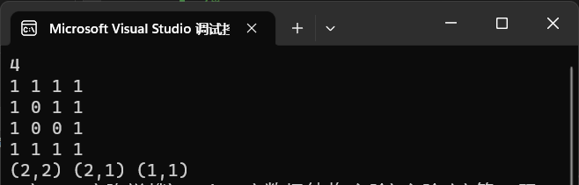
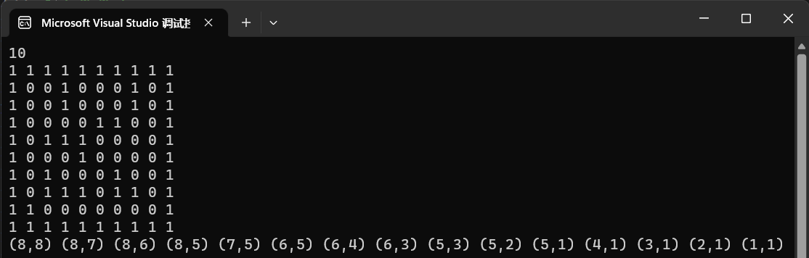
测试：
<2>
代码：
#include<iostream>
#include<vector>
#include<map>
#include<set>
#include<algorithm>
using namespace std;

struct Edge;
struct Gnode {
int value;//map中的key值
int in;//入度
int out;//出度
vector<Gnode*> nexts;
vector<Edge*> edges;
Gnode() {
value = 0;
in = 0;
out = 0;
}
Gnode(int val) {
value = val;
in = 0;
out = 0;
}
};

struct Edge {
Gnode* from;//起点
Gnode* to;//终点
int weight;//权
Edge() {
from = NULL;
to = NULL;
weight = 0;
}
Edge(int _weight, Gnode* _from, Gnode* _to) {
weight = _weight;
from = _from;
to = _to;
}
};

struct Graph {
public:
map<int, Gnode*> nodes;//储存所以点
set<Edge*> edges;//储存所有边
int treeflag;//判断是否为树
vector<int> visited;//判断是否访问过
};

Graph* CreateGraph(int matrix[][3], int n)
{
Graph* graph = new Graph;
graph->treeflag = 0;
for (int i = 0; i < n; i++)
{
int weight = matrix[i][0];
int from = matrix[i][1];
int to = matrix[i][2];
if (graph->nodes.find(from) == graph->nodes.end())
{
graph->nodes[from] = new Gnode(from);
}

if (graph->nodes.find(to) == graph->nodes.end())
{
graph->nodes[to] = new Gnode(to);
}

Gnode* fromnode = graph->nodes[from];
Gnode* tonode = graph->nodes[to];

Edge* newedge = new Edge(weight, fromnode, tonode);
fromnode->nexts.push_back(tonode);
fromnode->out++;
fromnode->edges.push_back(newedge);

graph->edges.insert(newedge);
}
for (int i = 0; i < graph->nodes.size(); i++) {
graph->visited.push_back(0);
}
return graph;
}

void visit(Gnode* node) {
cout << node->value << " ";
}

void CriticalPathSearch(Graph* graph, Gnode* node, Gnode* end, vector<Gnode*>path, vector<vector<Gnode*>>& CriticalPaths, int time, int& maxtime) {
if (node == end) {
if (time == maxtime) {
CriticalPaths.push_back(path);
}

if (time > maxtime) {
maxtime = time;
CriticalPaths.clear();
CriticalPaths.push_back(path);
}
return;
}
for (int i = 0; i < node->nexts.size(); i++) {
if (graph->visited[node->nexts[i]->value - 1] == 0) {
graph->visited[node->nexts[i]->value - 1] = 1;
path.push_back(node->nexts[i]);
int value = 0;
for (set<Edge*>::iterator it = graph->edges.begin(); it != graph->edges.end(); it++) {
Edge e = **it;
if (e.from == node && e.to == node->nexts[i])value = e.weight;
}
time += value;
CriticalPathSearch(graph, node->nexts[i], end, path, CriticalPaths, time, maxtime);
graph->visited[node->nexts[i]->value - 1] = 0;
path.pop_back();
time -= value;
}
}
}

bool cmp(vector<Gnode*> a, vector<Gnode*> b) {
return a.size() < b.size();
}

void CriticalPath(Graph* graph) {
for (int i = 0; i < graph->nodes.size(); i++) {
graph->visited[i] = 0;
}
int end = graph->nodes.size();
map<int, Gnode*>::iterator it;
it = graph->nodes.find(end);
Gnode* p = it->second;
it = graph->nodes.find(1);
vector<Gnode*> path;
path.push_back(it->second);
graph->visited[0] = 1;
vector<vector<Gnode*>> CriticalPaths;
int maxtime = 0;
CriticalPathSearch(graph, it->second, p, path, CriticalPaths, 0, maxtime);
if (CriticalPaths.size() == 0) {
cout << "该AOE网不完整" << endl;
return;
}
cout << "该AOE网的最早完成时间为：" << maxtime << endl;
cout << "关键路径为：" << endl;
for (int i = 0; i < CriticalPaths.size(); i++) {
for (int j = 0; j < CriticalPaths[i].size(); j++) {
cout << CriticalPaths[i][j]->value;
if (j < CriticalPaths[i].size() - 1)cout << "->";
else cout << endl;
}
}
}

int main() {
int m[15][3] = { {3,1,2},{4,1,3},{5,1,4},{6,2,5},{3,3,5},{4,3,6},{3,4,6},{6,4,9},{5,5,7},{4,5,8},{3,6,8},
{4,6,9},{5,7,10},{6,8,10},{4,9,10} };
Graph* a = CreateGraph(m, 15);
CriticalPath(a);
}
测试：
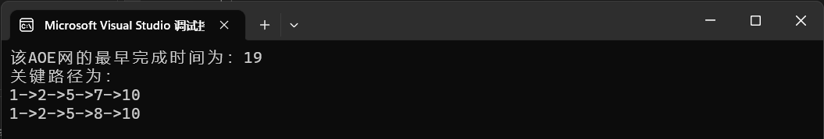

三、实验结果分析与思考∶
图的存储结构邻接表和邻接矩阵的设计与实现，基本运算的实现，发现根据不同的题目要求，使用不同的存储结构，虽然都是图，但每道题对图的要求有细微不同，根据这些特点，找到时空效率更高的算法。
实验成绩∶

指导教师签名：
年 月 日

